# Review Apps

## Steps

### Prerequisites

Create a GitHub account

Install <https://nodejs.org/en/>

Install Heroku CLI

### NodeJS App

<https://github.com/rohitbhardwaj/flow-demo>

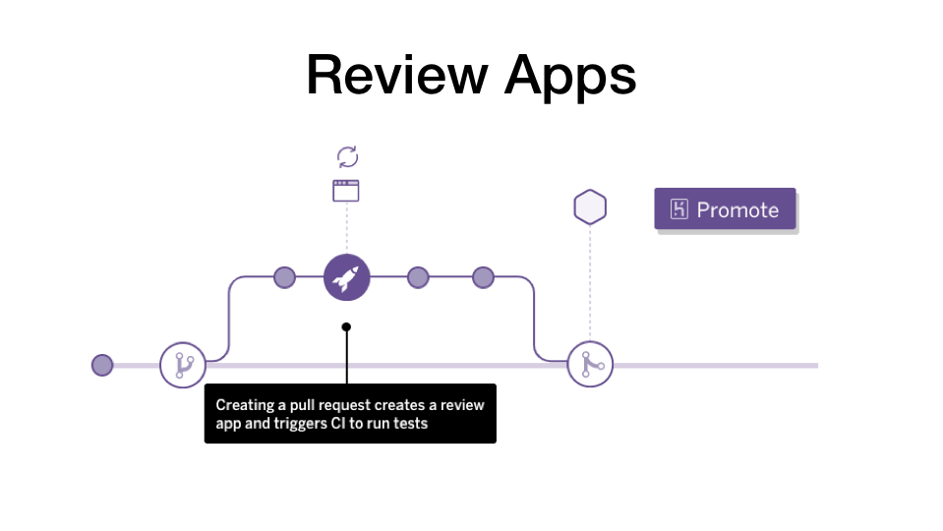

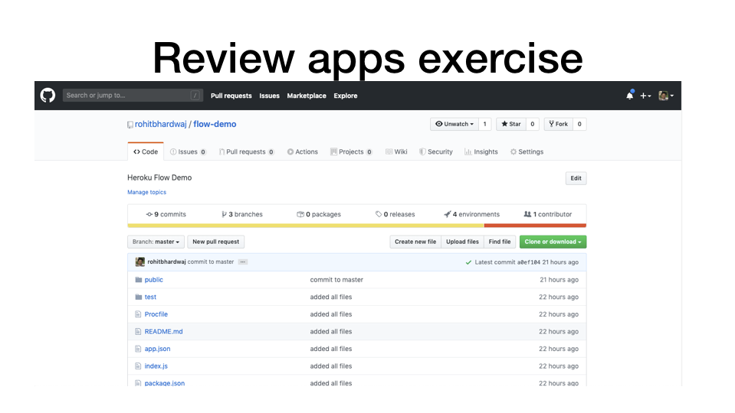

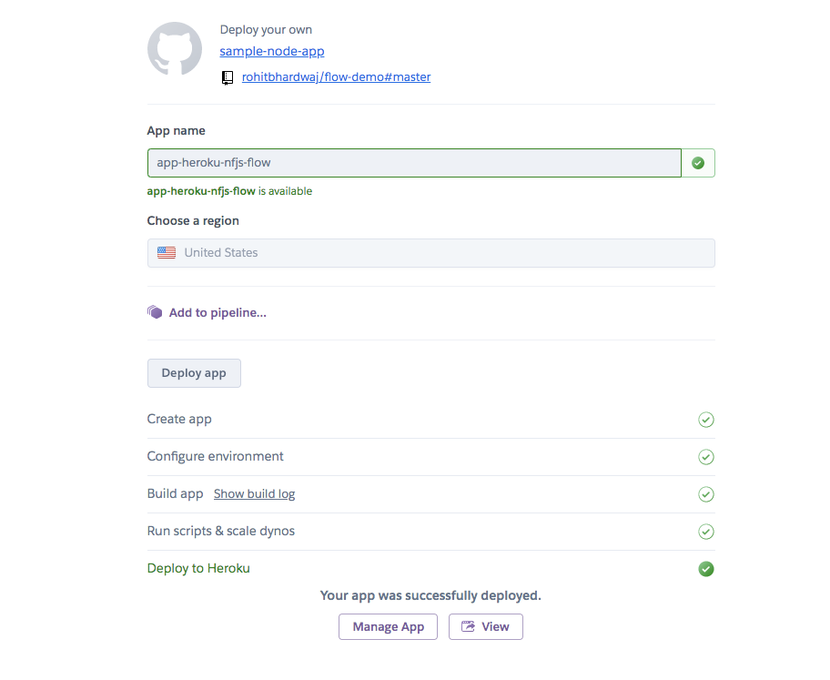

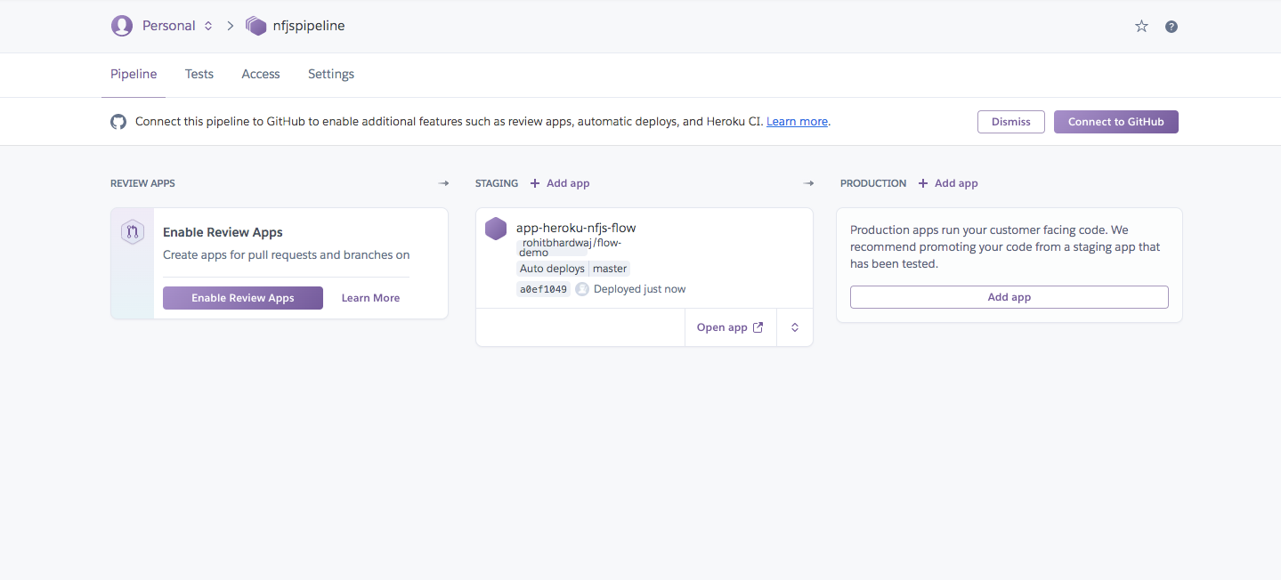

Remember to also connect to Github from Heroku pipeline

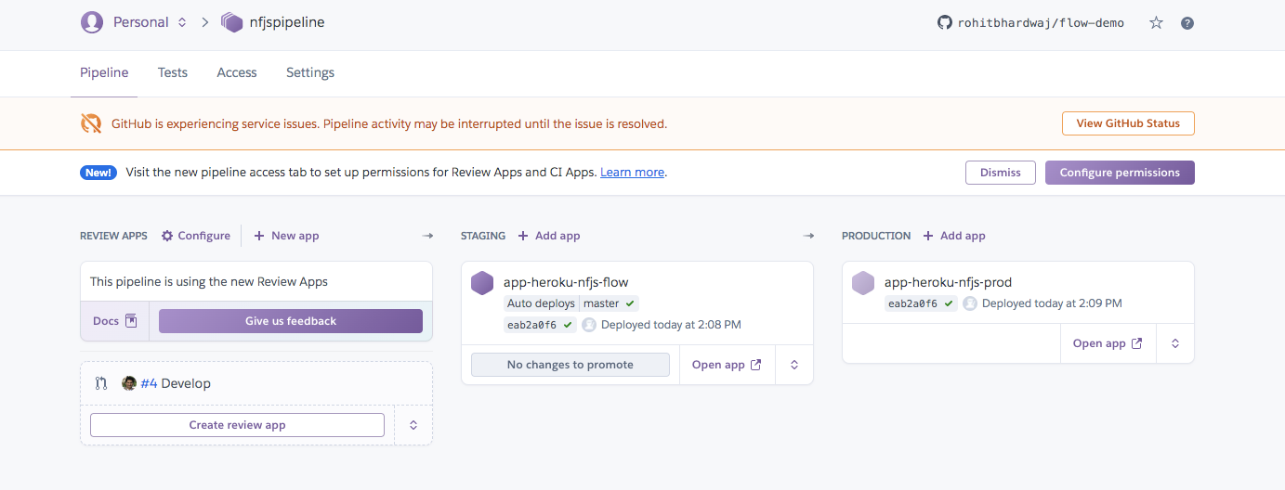

Configure permissions if needed for others

